**Money Matters: A Personal Finance Management App**

**K.Balaji - 126176715ABAC238993492271106508C E.Dhanush-E1F56622184546BAE364F6A3C162486B V.Velmani-54C9552342AF876905649F6F56A29AA5 G.Prasanna-38493E78D365DD0AEAA4A7606858FB43 K.Ragul - 93A1B8D9BF127D8AF6F49D8AA086C5BC**

### Money Matters: A Personal Finance Management App

Project Description:

The app allows user to keep track of their expenses and accounts, and provides an overview of their financial status.Users can set a budget for various expenses and view their progress towards it.

Learning Outcomes :

By end of this project:

* You’ll be able to work on Android studio and build an app.
* You’ll be able to integrate the database accordingly.

Project Workflow:

* Users register into the application.
* After registration , user logins into the application.
* User enters into the main page
* User can view the subject themes on selecting theme he can read about it.

Note:

To complete the project you need to finish up the tasks listed below:

Tasks:

1.Required initial steps

2.Creating a new project.

3.Adding required dependencies.

4.Creating the database classes.

5.Building application UI and connecting to database.

6.Using AndroidManifest.xml

7.Running the application.

**Required initial steps**

Required initial steps:

<https://developer.android.com/studio/install>

**Creating a new project**

Creating a new project

Step 1 : Android studio > File > New > New Project > Empty Compose Activity

Step 2 : Click on Next button.

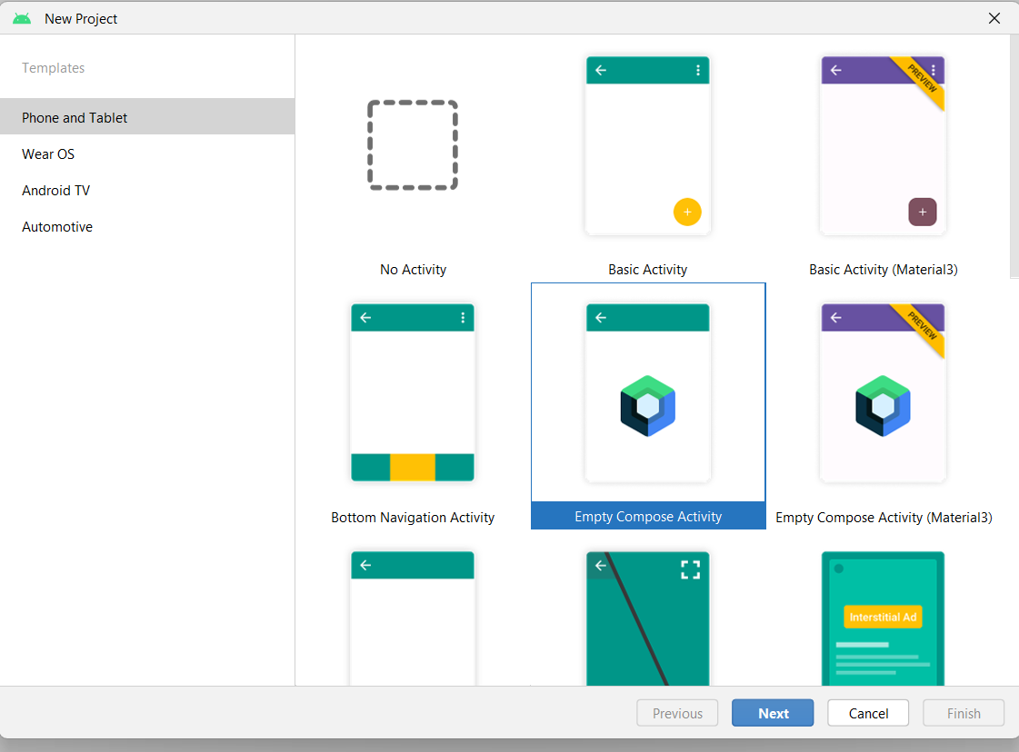

Step 3 : Give name to the new project.

Step 4 : Give the Minimum SDK value

Step 5 : Click Finish

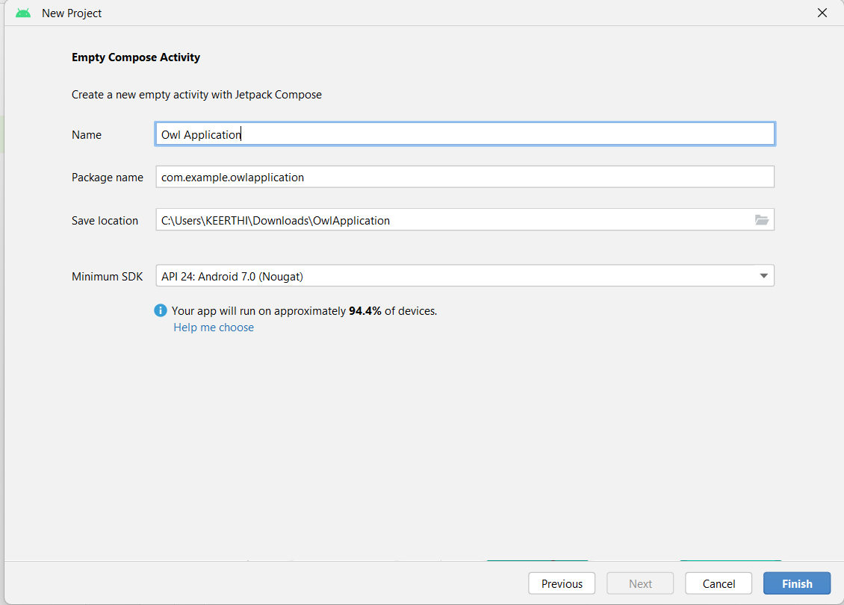

Main activity file

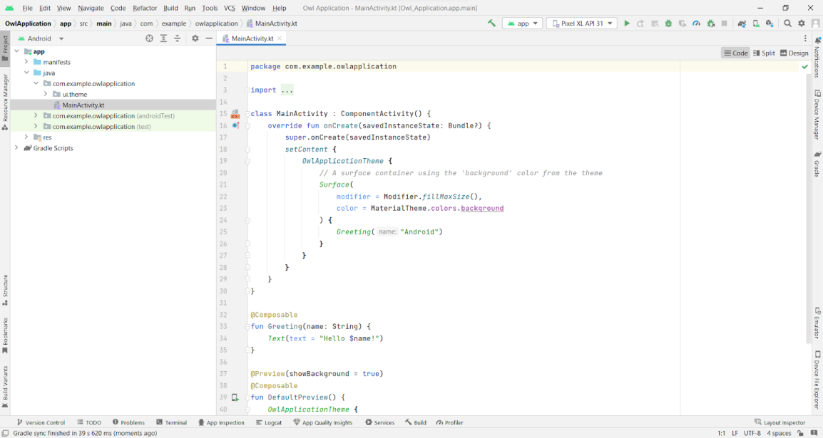

**Adding required dependencies**

This milestones explains about adding required dependencies.

**Gradle scripts > build.gradle(Module :app)**

Gradle scripts > build.gradle(Module :app)

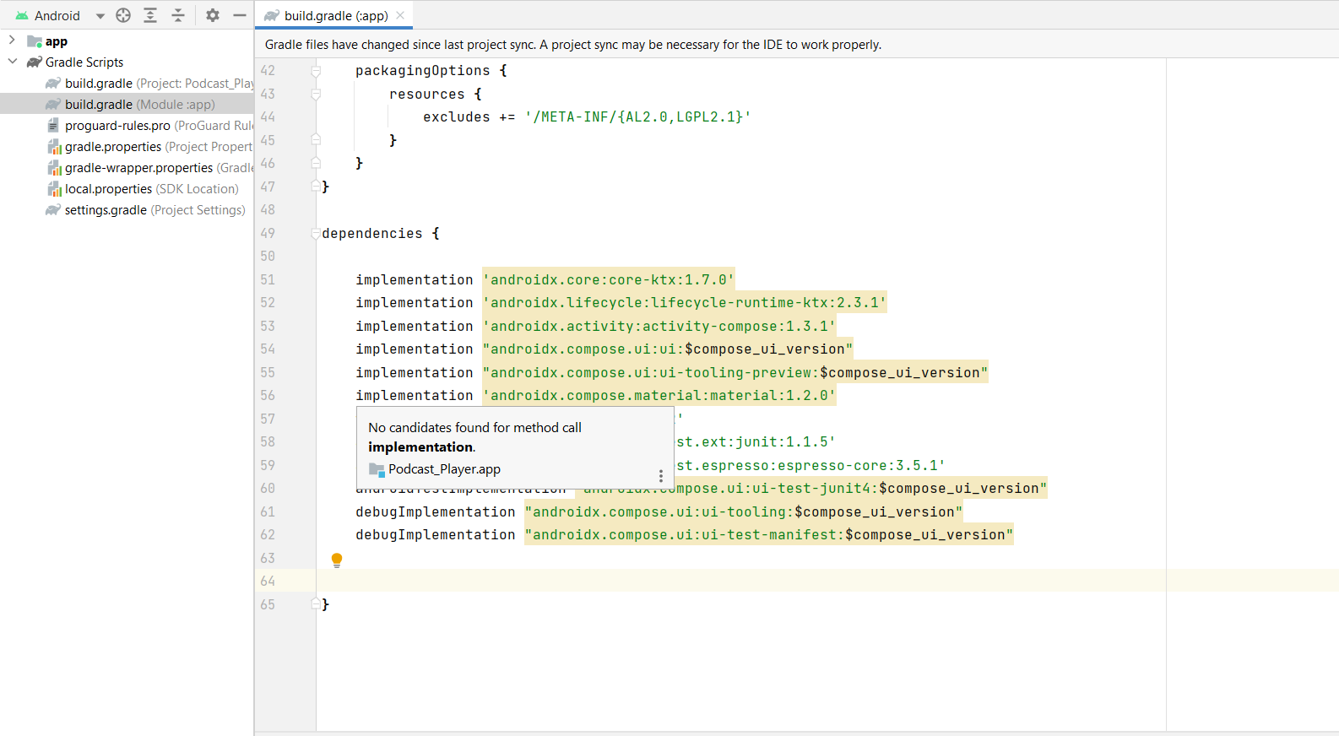

**Adding room dependencies**

Adding room dependencies

Add the below code in dependencies

// Adding Room dependencies

implementation 'androidx.room:room-common:2.5.0'

implementation 'androidx.room:room-ktx:2.5.0'

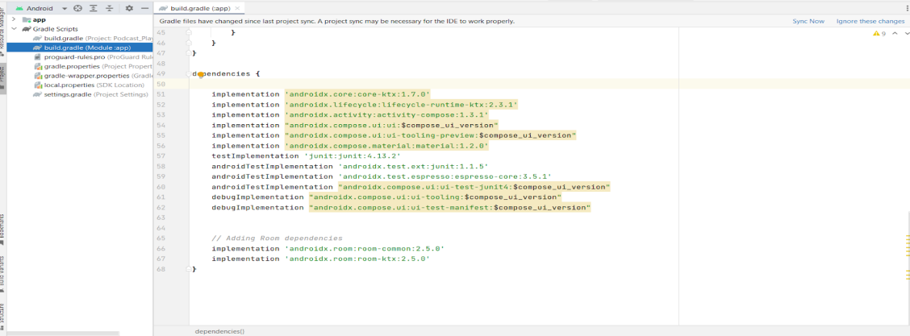

Step 3 : Click on Sync now

**Creating the database classes**

This milestone explains about Creating the database classes

**Create User data class**

Create User data class

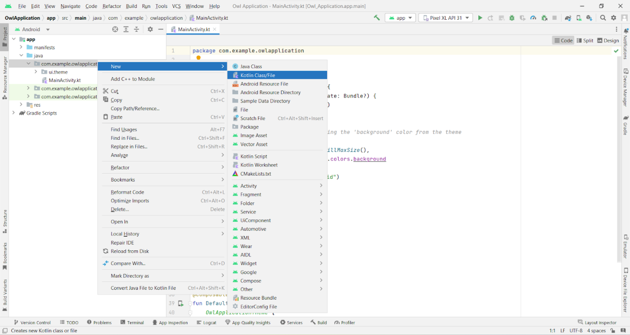

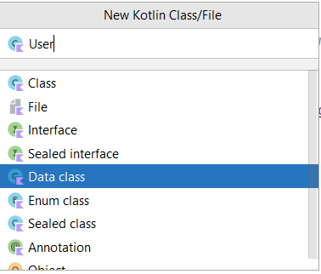

User data class code:

<https://github.com/smartinternz02/Expense-Tracker-App/blob/master/app/src/main/java/com/example/expensestracker/User.kt>

**Create an UserDatabase class**

Create an UserDatabase class

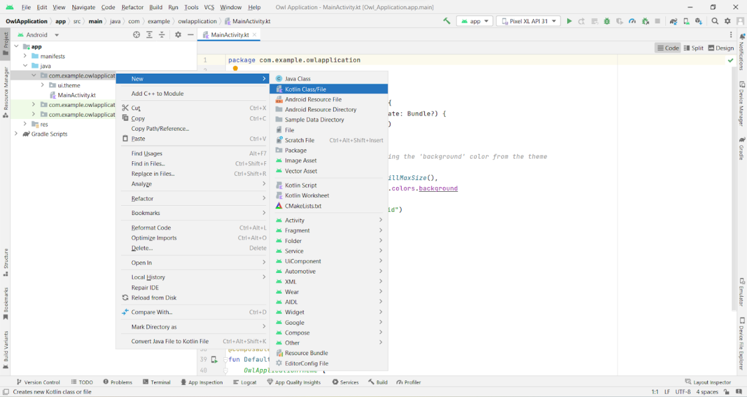

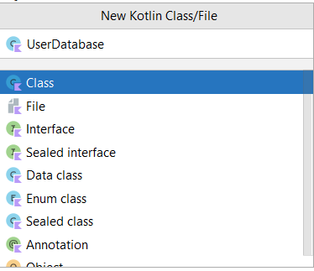

UserDatabase class code :

<https://github.com/smartinternz02/Expense-Tracker-App/blob/master/app/src/main/java/com/example/expensestracker/UserDatabase.kt>

**Create an UserDatabaseHelper class**

Create an UserDatabaseHelper class

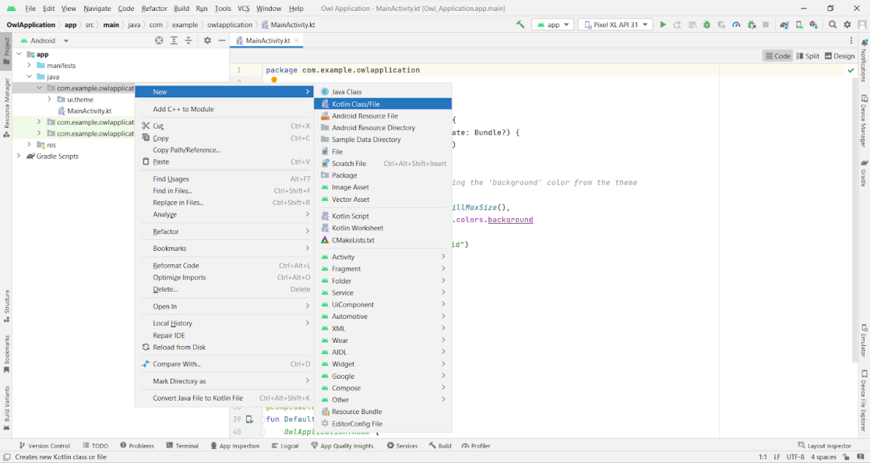

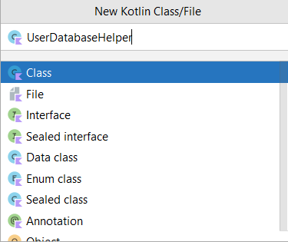

UserDatabaseHelper class code :

<https://github.com/smartinternz02/Expense-Tracker-App/blob/master/app/src/main/java/com/example/expensestracker/UserDatabaseHelper.kt>

**Building application UI and connecting to database**

This milestone explains about Building application UI and connecting to database.

**Creating LoginActivity.kt with database**

**Creating LoginActivity.kt with database**

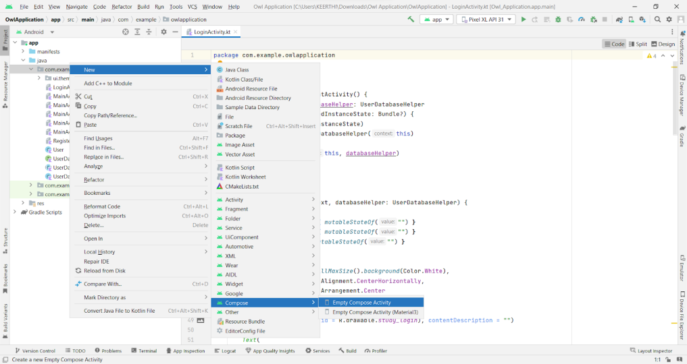

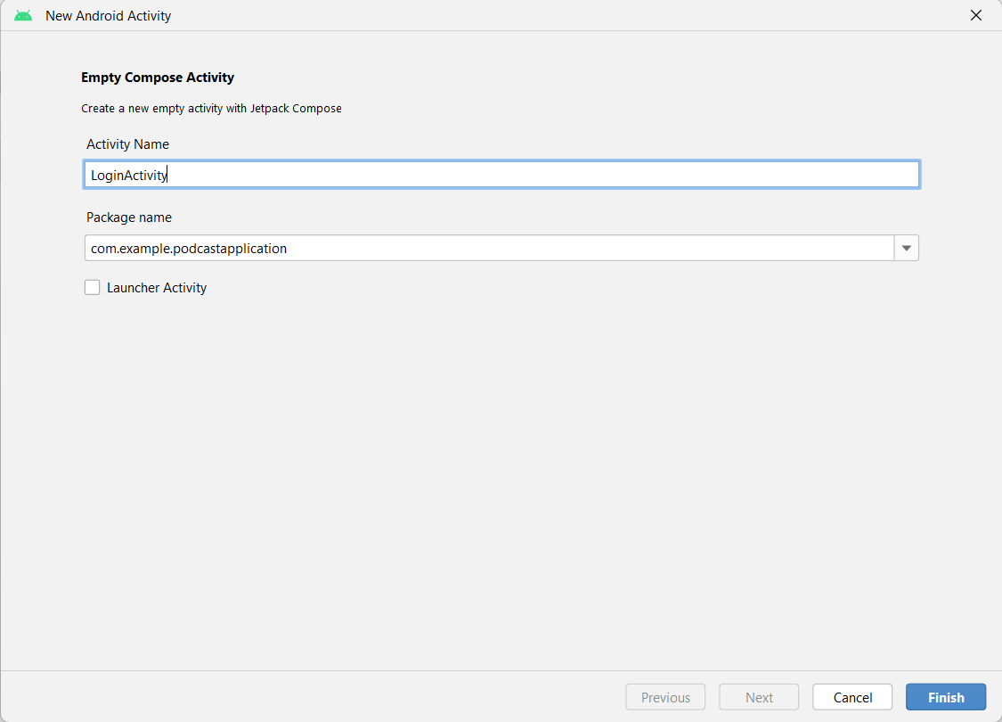

**Database connection in LoginActivity.kt**

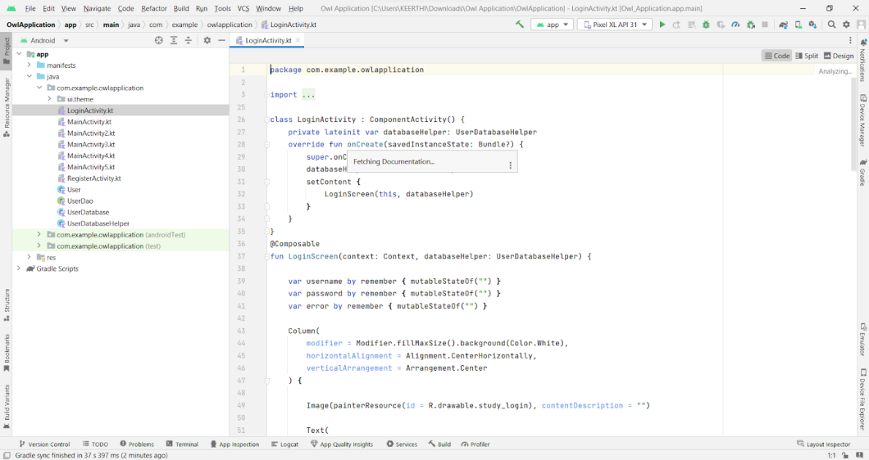

Complete code in below link:

<https://github.com/smartinternz02/Expense-Tracker-App/blob/master/app/src/main/java/com/example/expensestracker/LoginActivity.kt>

**Creating RegisterActivity.kt with database**

Creating RegisterActivity.kt with database

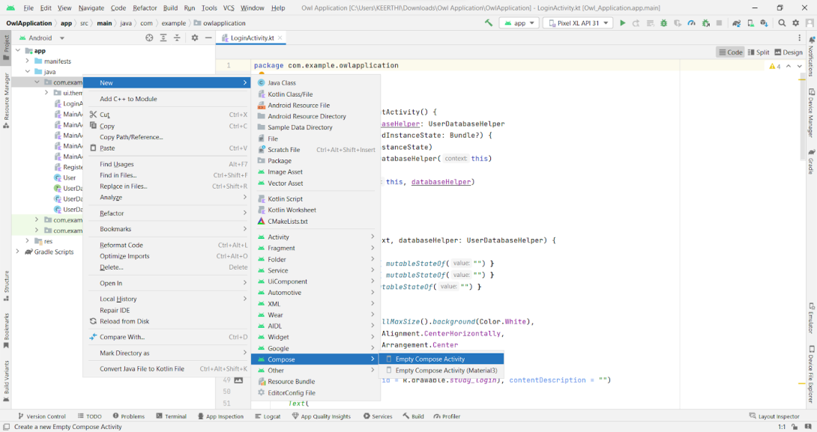

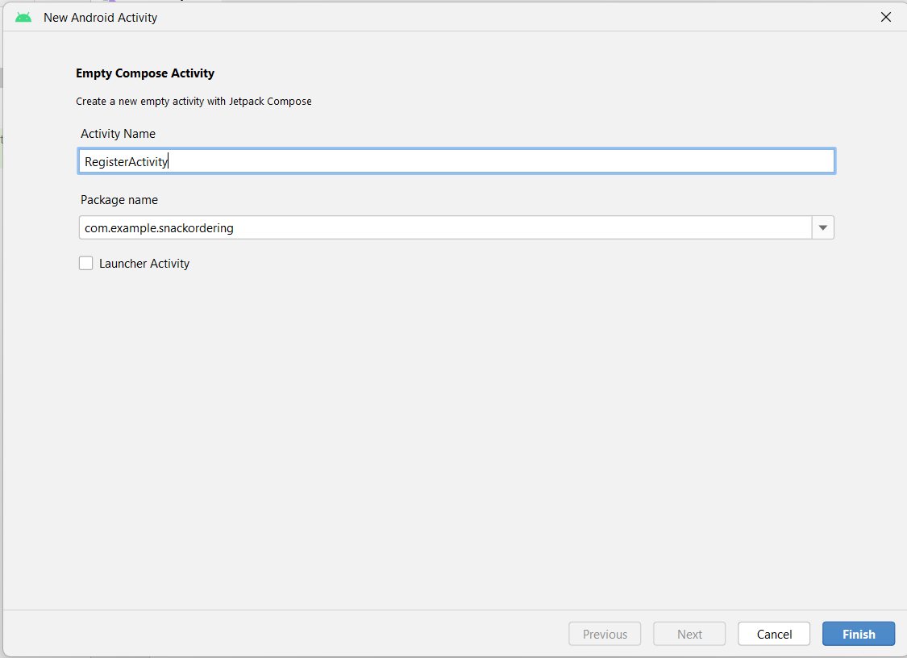

Database connection in RegisterActivity.kt

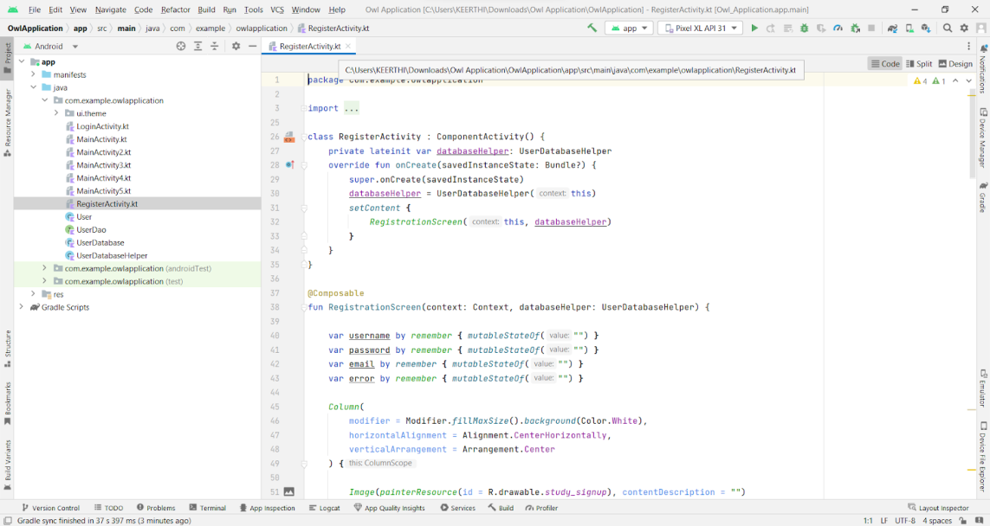

Complete code in below link:

<https://github.com/smartinternz02/Expense-Tracker-App/blob/master/app/src/main/java/com/example/expensestracker/RegisterActivity.kt>

### Creating LoginActivity.kt with database

Creating LoginActivity.kt with database

Complete Code :

<https://github.com/smartinternz02/Expense-Tracker-App/blob/master/app/src/main/java/com/example/expensestracker/LoginActivity.kt>

### Creating RegisterActivity.kt with database

Creating RegisterActivity.kt with database

Complete code in below link:

<https://github.com/smartinternz02/Expense-Tracker-App/blob/master/app/src/main/java/com/example/expensestracker/RegisterActivity.kt>

**Creating MainActivity.kt file**

Creating MainActivity.kt file

In MainActivity.kt file the main application is developed

* Before creating UI we need to add some images in drawables
* Download the required drawable from the code:
* <https://github.com/smartinternz02/Expense-Tracker-App/tree/master/app/src/main/res/drawable>

Complete code in below link:

<https://github.com/smartinternz02/Expense-Tracker-App/blob/master/app/src/main/java/com/example/expensestracker/MainActivity.kt>

### Creating AddExpensesActivity.kt file

Creating AddExpensesActivity.kt file

Complete code in below link :

[https://github.com/smartinternz02/Expense-Tracker-App/blob/master/app/src/main/java/com/example/expensestracker/AddExpensesActivity.k](https://github.com/smartinternz02/Expense-Tracker-App/blob/master/app/src/main/java/com/example/expensestracker/AddExpensesActivity.kt)

### Creating SetLimitActivity.kt file

Creating SetLimitActivity.kt file

Complete code in below link :

<https://github.com/smartinternz02/Expense-Tracker-App/blob/master/app/src/main/java/com/example/expensestracker/SetLimitActivity.kt>

### Modifying AndroidManifest.xml

Modifying AndroidManifest.xml

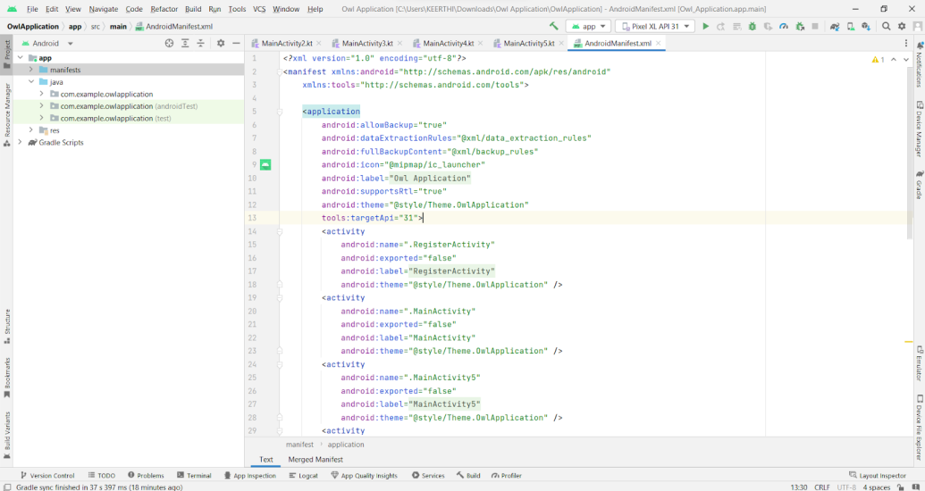

When we run the app we will get the MainActivity.kt file as our first screen , but we want LoginActivity.kt , So we need to change in AndroidManifest.xml.

Changed AndroidManifest.xml

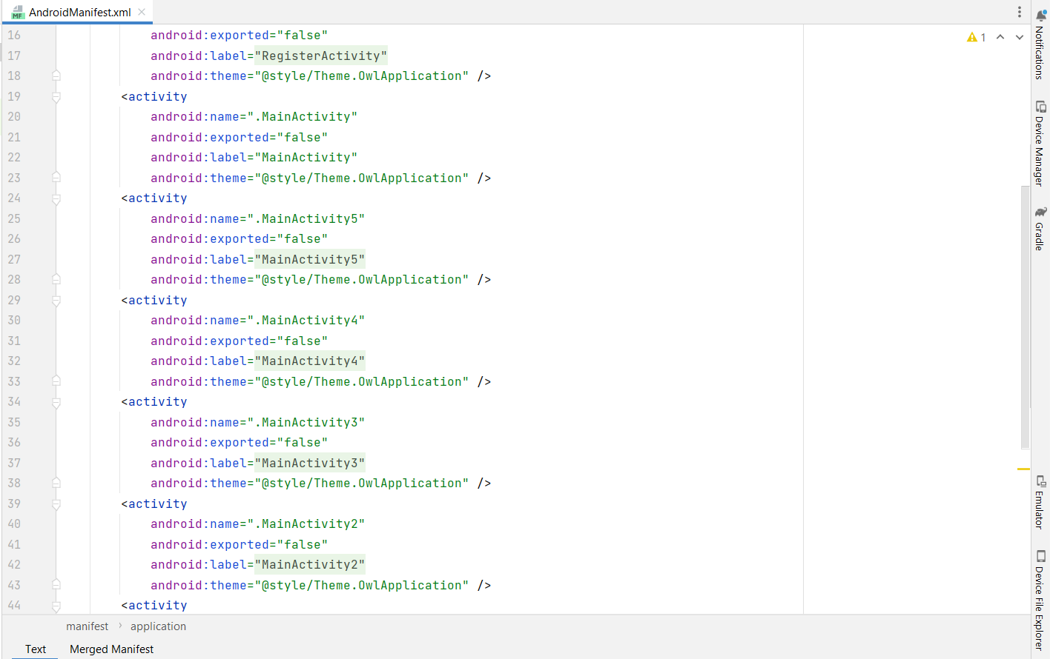

Complete AndroidManifest.xml code:

<https://github.com/smartinternz02/Travel-Plan-App/blob/master/app/src/main/AndroidManifest.xml>

### Running the application

This milestone explains about running the application.

### Run apps on a hardware device

Run apps on a hardware device

<https://developer.android.com/studio/run/device>

### Run the application in Mobile

Run the application in Mobile

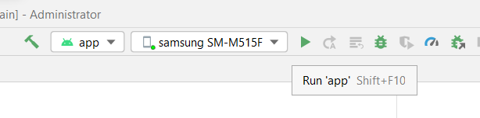

Complete Project Link: <https://github.com/smartinternz02/Expense-Tracker-App>

Final Output of the Application :

Login Page :

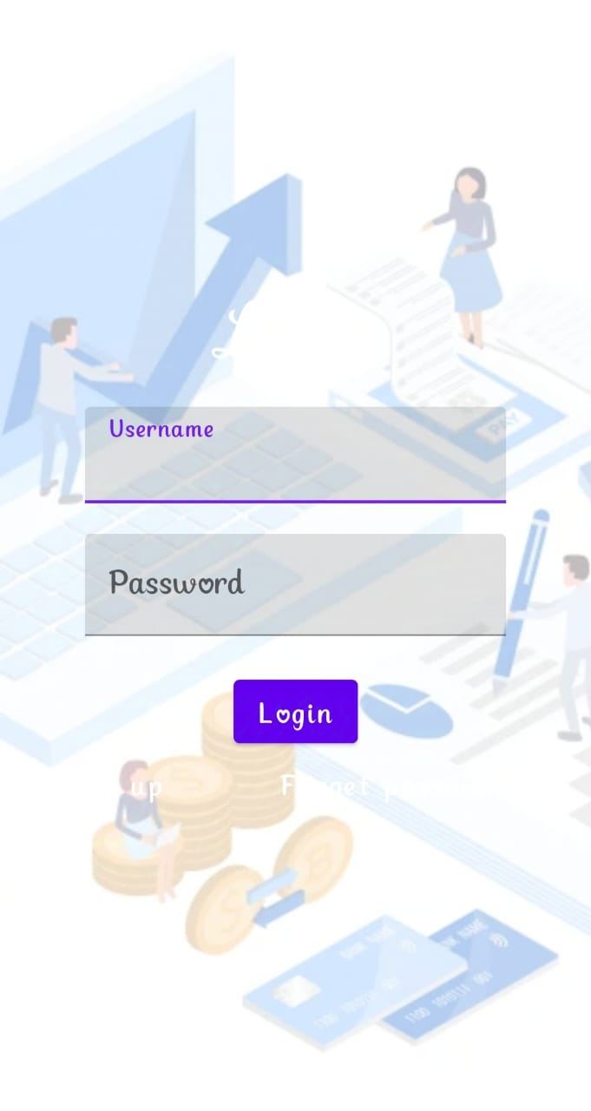

Main Page :

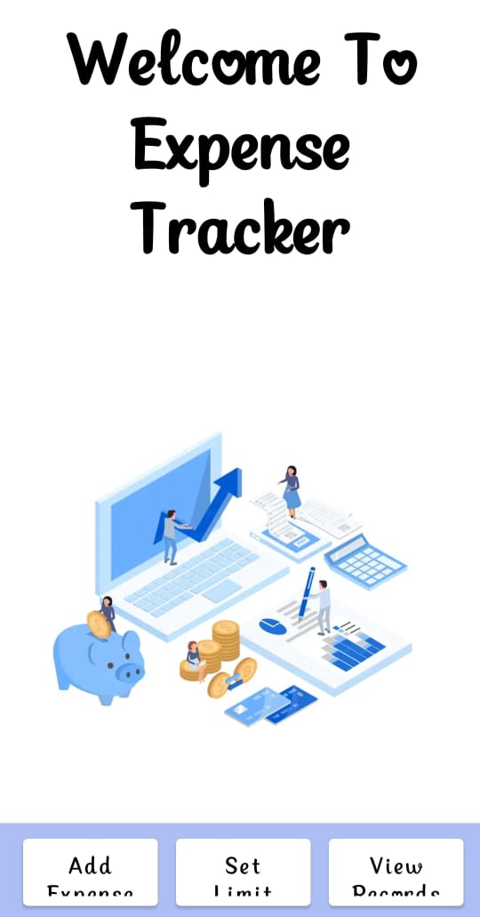

Add expense Page :

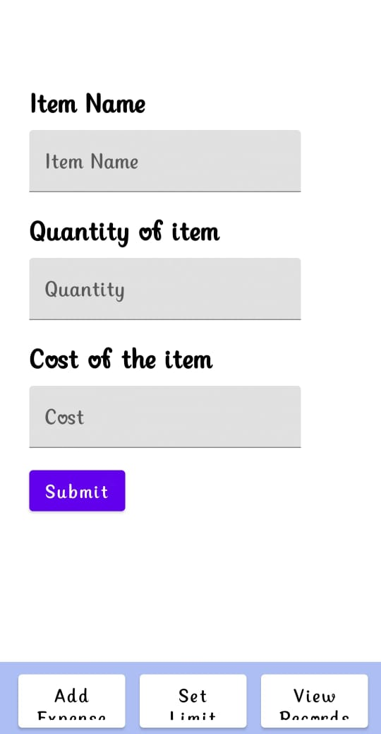

Set Limit page :

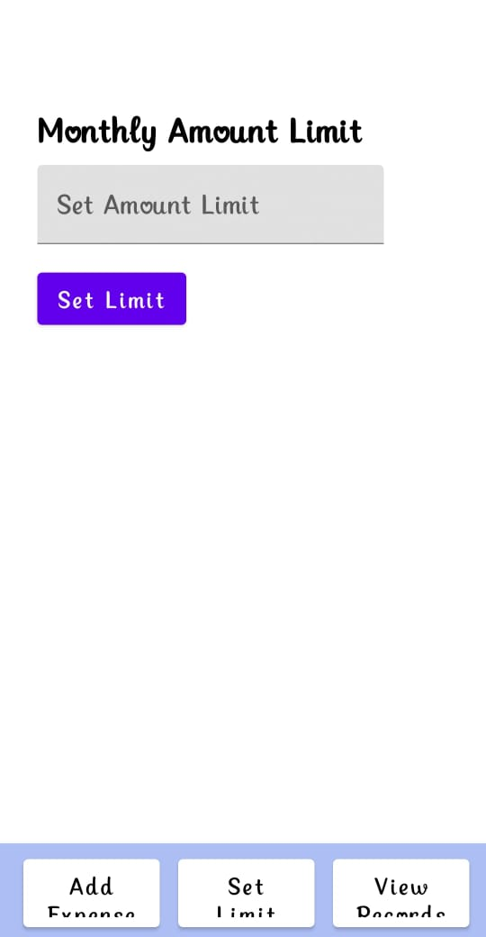

View Records Page:

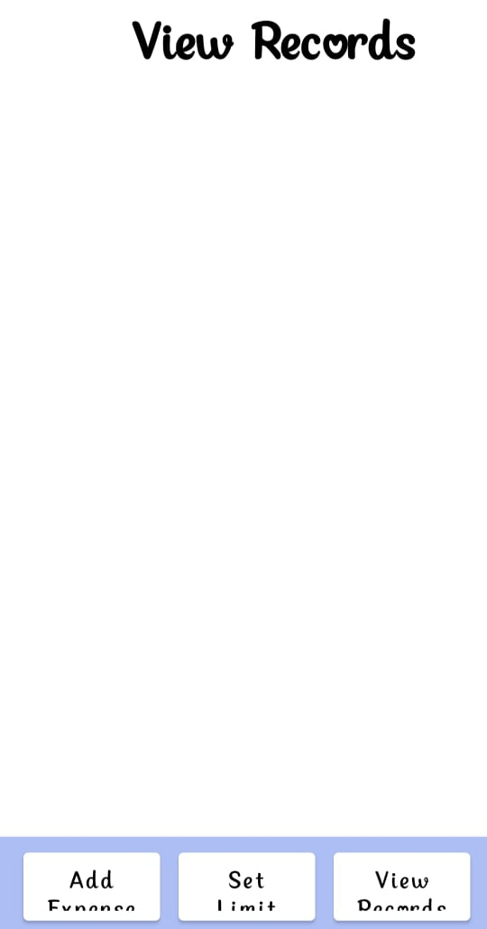

**Conclusion:**

To Control our expenses of day to life we have to use the expense tracker app and it has useful to control our expense.

**\*\*THANK YOU!\*\***